Cohort studies
In studies of health effects of air pollution exposure in the United States, a common source of information is from prospective cohort studies.^{1–6} Time series studies have also been used to demonstrate short-term air pollution exposure effects, though evidence of the effect of long-term exposure to air pollution is obtained from cohort studies.⁷ Whereas time series studies of air pollution pick up on mortality which is triggered by recent air pollution (e.g., dying from complications of having bronchitis during an elevated air pollution episode), cohort studies are also able to attribute mortality of the decedent due to a long-term cumulative exposure, which is not necessarily associated with recent elevated air pollution levels.⁷ For the association between air pollution and mortality, cohort studies arguably provide a more complete assessment than time-series studies of the short- and long-term impact of air pollution on mortality.⁷
Though air pollution’s deleterious cumulative effects are well-recognised,^{1–6} there is strong evidence that humans adapt to their local temperature, without any long-term impacts.⁸ Since short-term effects of temperature on mortality are of primary interest, time series studies are suited to the investigation of temperature and mortality. I discuss potential future work on cohort studies and the temperature-mortality relationship in Section 8.4.

Confounders, effect modifiers and mediators

Confounders
A confounder is a variable that influences the exposure of interest (in my case anomalous monthly temperature) as well as the outcome variable (in my case death rates).⁹ Without adjusting for confounders in an analysis, the real effect of the original exposure could be over- or underestimated, depending on how the confounders are associated with the original exposure and the outcome.
Figure 33 displays a Directed Acyclic Graph (DAG) relevant to considerations in my thesis. DAGs are commonly used in the epidemiological community to identify variables which must be measured and controlled for to obtain unconfounded effect estimates.¹⁰ In the DAG in Figure 33, both air pollution and temperature are exposures manifested by the physics of the atmosphere on Earth, summarised in Figure 33 by the term ‘weather regimes’. Temperature can also affect levels of air pollution. Weather regimes are difficult to quantify, and are therefore difficult to adjust for. If appropriate adjustments cannot be made to account for the common influence of weather regimes, then the air pollution path is not fully blocked, and it should be adjusted for in my statistical model. This would be particularly relevant for cardiorespiratory diseases, of which known pathways between pollution and mortality are well-established.
In my model, in particular in terms described in Sections 5.4.2-5.4.4, I implicitly adjusted any determinant of mortality that is state-, month-, or state-month specific. Therefore, anything that affects mortality and changes linearly over time is adjusted for. Beyond this, my choice of exposure, i.e., temperature anomaly, explains variation in mortality in equivalent months beyond what is already accounted for. Only factors that have the same anomaly as monthly temperature remain. However, air pollution may be one such factor.
While air pollution levels may affect the temperature-mortality relationship, I have not included this in my analysis, due to the air pollution data I found only being annual data and not covering my entire study period (1980-2016). A recent study I co-authored using air pollution data to examine changes in life expectancy used data from 1999 onwards only.¹¹ There would be other potential meteorological exposure variables which may be relevant if the pathway is not fully blocked by the month stratification. These could include, for example, relative humidity, amount of sunlight, and rainfall.
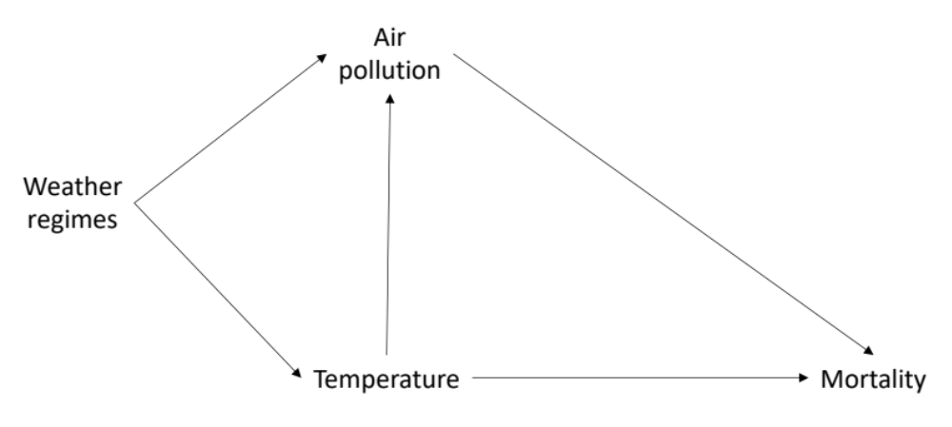
Figure 33. DAG describing the potential confounding of air pollution on a study of tempearture and mortality.

Effect modifiers
Effect modification is where the magnitude of an exposure effect varies across levels of another variable.⁹ In the model I used here for my thesis, I accounted for the potential effect modification by month (as well as defining temperature anomaly by month), sex and age group (Equation 4 as used in Chapters 6 and 7) and by state (Equation 9 as used in Chapter 7), based on previous research explained in Chapter 2. In my thesis, I did not examine the effect modification by air pollution levels; rather, my results in Chapters 6 and 7 give the average effect across distributions of air pollution levels. This is analogous to summarising various age-modified risks by a single value to represent risk across all ages, common in epidemiological studies. Other exposures which might also modify the temperature-mortality relationship could also include relative humidity, amount of sunlight, and rainfall.
Depending on the cause of death, additional factors may be relevant to include in further analysis, which may also modify the association between anomalous temperature and death rates. For my study of injuries in Chapter 6, relevant effect modifiers could include coverage of rivers and lakes in a state, road density or availability of alcohol, alcohol consumption, air conditioning prevalence, as some injury deaths may be more or less likely depending on the presence of these state characteristics. For my study of cardiorespiratory diseases and cancers in Chapter 7, relevant effect modifiers could include air conditioning use, obesity prevalence, as well as hospital access.

Mediators
A mediator is a variable along a causal pathway between the exposure and the outcome.⁹ For example, warmer temperatures may result in people drinking more alcohol, and alcohol impairs a driver’s ability to drive without getting into transport accidents. Increases in temperature and alcohol levels in a driver’s blood both increase the chances of dying, but increases in temperature also affect the potential for the population to drink alcohol.
The fact that some potential mediators are not included in the model, suggests that care is required when proposing mechanisms of causation between temperature and mortality for various causes of death. The causality mechanism may be direct, i.e., temperature directly affects mortality, or it may be indirect, i.e., temperature affects another exposure or variable, which in turn affects mortality. Whichever of the two it may be, the predictive value of the work is not reduced. Rather, further exploration of the mechanisms behind the association is required.

Works cited
1. Dockery, D. W. et al. An association between air pollution and mortality in six U.S. cities. N. Engl. J. Med. 329, 1753–9 (1993).
2. Pope, C. A. et al. Lung cancer, cardiopulmonary mortality, and long-term exposure to fine particulate air pollution. JAMA 287, 1132–1141 (2002).
3. Pope, C. A. & Dockery, D. W. Health effects of fine particulate air pollution: lines that connect. J. Air Waste Manag. Assoc. (2006). doi:10.1080/10473289.2006.10464485
4. Brook, R. D. et al. Particulate matter air pollution and cardiovascular disease: an update to the scientific statement from the american heart association. Circulation (2010). doi:10.1161/CIR.0b013e3181dbece1
5. Burnett, R. et al. Global estimates of mortality associated with long-term exposure to outdoor fine particulate matter. Proc. Natl. Acad. Sci. (2018). doi:10.1073/pnas.1803222115
6. Krewski, D. et al. Extended follow-up and spatial analysis of the American Cancer Society study linking particulate air pollution and mortality. Res. Rep. Health. Eff. Inst. (2009).
7. Künzli, N. et al. Assessment of deaths attributable to air pollution: should we use risk estimates based on time series or on cohort studies? Am. J. Epidemiol. (2001). doi:10.1093/aje/153.11.1050
8. Gasparrini, A. et al. Mortality risk attributable to high and low ambient temperature: a multicountry observational study. Lancet 386, 369–375 (2015).
9. Rothman, K. J., Greenland, S. & Associate, T. L. L. Modern Epidemiology: 3rd Edition. Lippincott Williams & Wilkins (2014). doi:10.1002/hast.292
10. Greenland, S., Pearl, J. & Robins, J. M. Causal diagrams for epidemiologic research. Epidemiology (1999). doi:10.1097/00001648-199901000-00008
11. Bennett, J. E. et al. National and county life expectancy loss from particulate matter pollution in the USA. PLOS Med. (2019).

